MINI PROJECT

ON

ARITHMETIC CALCULATOR

SUBMITTED BY

NANDHAN. J. S

NC.SC.U4CSE24118

FOR

23CSE101-COMPUTATIONAL PROBLEM SOLVING

I-SEMESTER

B.TECH CSE

SCHOOL OF COMPUTING

AMRITA VISWA VIDYAPEETHAM, NAGERCOIL

INDEX

SL.NO CHAPTER NAME PAGE NO.

1. Introduction
2. Problem statement
3. Objectives
4. Python libraries used in this project
5. Modules of project
6. Code
7. Output screenshots
8. Application of the project
9. Limitations of the project
10. Bibliography
11. GitHub link of the project

INTRODUCTION

The Simple Arithmetic Calculator is a basic tool developed using Python to perform addition, subtraction, multiplication, and division. This project shows how Python can be used to create simple and useful applications. The calculator is easy to use and provides accurate results, making it a great example for beginners to learn programming and arithmetic operations.

PROBLEM STATEMENT

People often need a quick and easy way to solve basic math problems like addition, subtraction, multiplication, and division. Many existing tools are either too complicated or not user-friendly for simple tasks. This project aims to create a basic arithmetic calculator that is simple, easy to use, and helpful for everyday calculations.

OBJECTIVES

1. Build a calculator that can do addition, subtraction, multiplication, and division.
2. Make the calculator easy to use for everyone.
3. Ensure the calculator gives correct results every time.
4. Create a simple and efficient tool for daily math tasks.
5. Show how basic programming is used to create the calculator.

PYTHON LIBRARIES USED IN THIS PROJECT

The code uses the **math** library to perform basic arithmetic operations like addition, subtraction, multiplication, and division. It handles division by zero and ensures user inputs are treated as numbers for accurate calculations, making the calculator reliable and easy to use.

MODULES OF PROJECT

The project includes modules for basic arithmetic operations:**add(x, y), subtract(x, y), multiply(x, y),** and **divide(x, y),** which perform addition, subtraction, multiplication, and division, respectively. The **divide(x, y)** function also handles division by zero. The **calculator()** module provides the interface for users to input numbers and select operations. It manages user input, calls the appropriate arithmetic function, and handles errors like invalid input and division by zero, making it a simple and reliable tool for basic calculations.

CODE

import math

def add(x, y):

    return x + y

def subtract(x, y):

    return x - y

def multiply(x, y):

    return x * y

def divide(x, y):

    if y == 0:

        return "Error! Division by zero."

    return x / y

def calculator():

    while True:

        print("\nSelect operation:")

        print("1. Add")

        print("2. Subtract")

        print("3. Multiply")

        print("4. Divide")

        print("5. Exit")

        choice = input("Enter choice (1/2/3/4/5): ")

        if choice == '5':

            print("Exiting the calculator. Goodbye!")

            break

        if choice in ('1', '2', '3', '4'):

            try:

                num1 = float(input("Enter first number: "))

                num2 = float(input("Enter second number: "))

            except ValueError:

                print("Invalid input! Please enter numeric values.")

                continue

            if choice == '1':

                print(f"The result is: {add(num1, num2)}")

            elif choice == '2':

                print(f"The result is: {subtract(num1, num2)}")

            elif choice == '3':

                print(f"The result is: {multiply(num1, num2)}")

            elif choice == '4':

                result = divide(num1, num2)

                if isinstance(result, str):

                    print(result)

                else:

                    print(f"The result is: {result}")

        else:

            print("Invalid choice! Please select a valid option.")

if __name__ == "__main__":

    calculator()

OUTPUT SCREENSHOTS

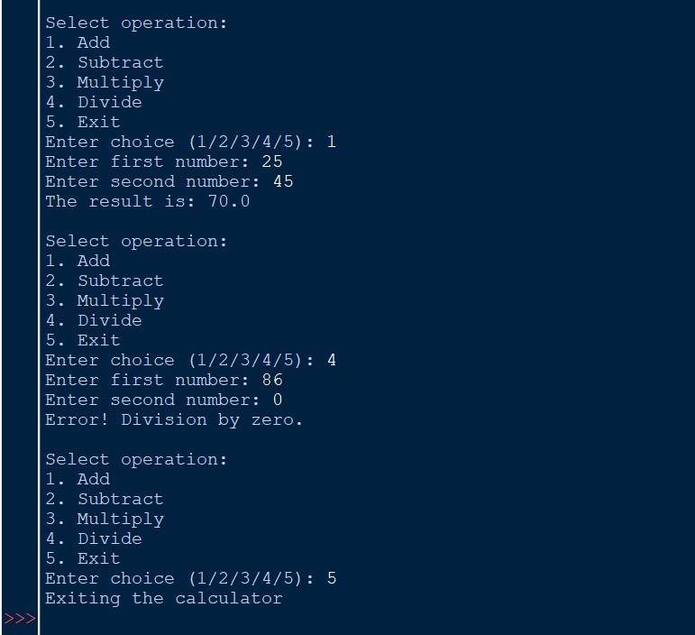

APPLICATIONS OF THE PROJECT

This arithmetic calculator code is useful for performing basic operations like addition, subtraction, multiplication, and division, making it handy for quick calculations. It’s a great learning tool for Python beginners, teaching concepts like functions, loops, and error handling. It’s also a good way to practice programming and build modular code.

LIMITATIONS OF THE PROJECT

This code has some limitations. It only supports basic operations like addition, subtraction, multiplication, and division, with no advanced features like square roots or exponents. It doesn’t have a user-friendly graphical interface and doesn’t handle complex numbers or very large inputs well. Users must enter inputs manually for each calculation, which can be time-consuming, and the error handling is basic and could be improved.

BIBLIOGRAPHY

1. **Python Documentation**:  
   Used for understanding Python syntax and functions.  
   [https://docs.python.org](https://docs.python.org/)
2. **Math Library Documentation**:  
   Referenced for mathematical operations.  
   <https://docs.python.org/3/library/math.html>
3. **Online Tutorials**:  
   Learning resources like W3Schools and GeeksforGeeks helped in building the calculator.
   * <https://www.w3schools.com/python/>
   * <https://www.geeksforgeeks.org/python-programming-language/>

GITHUB LINK OF THE PROJECT

<https://github.com/Nandhan616/Mini-project-Calculator->